**Perform Exploratory Data Analysis (EDA) on the data AMEO**

**aspiring_minds_employability_outcomes_2015**

* **The dataset was released by Aspiring Minds from the Aspiring Mind Employment Outcome 2015 (AMEO). The study is primarily limited only to students with engineering disciplines. The dataset contains the employment outcomes of engineering graduates as dependent variables (Salary, Job Titles, and Job Locations) along with the standardized scores from three different areas – cognitive skills, technical skills and personality skills. The dataset also contains demographic features. The dataset contains around 40 independent variables and 4000 data points. The independent variables are both continuous and categorical in nature. The dataset contains a unique identifier for each candidate. Below mentioned table contains the details for the original dataset.**

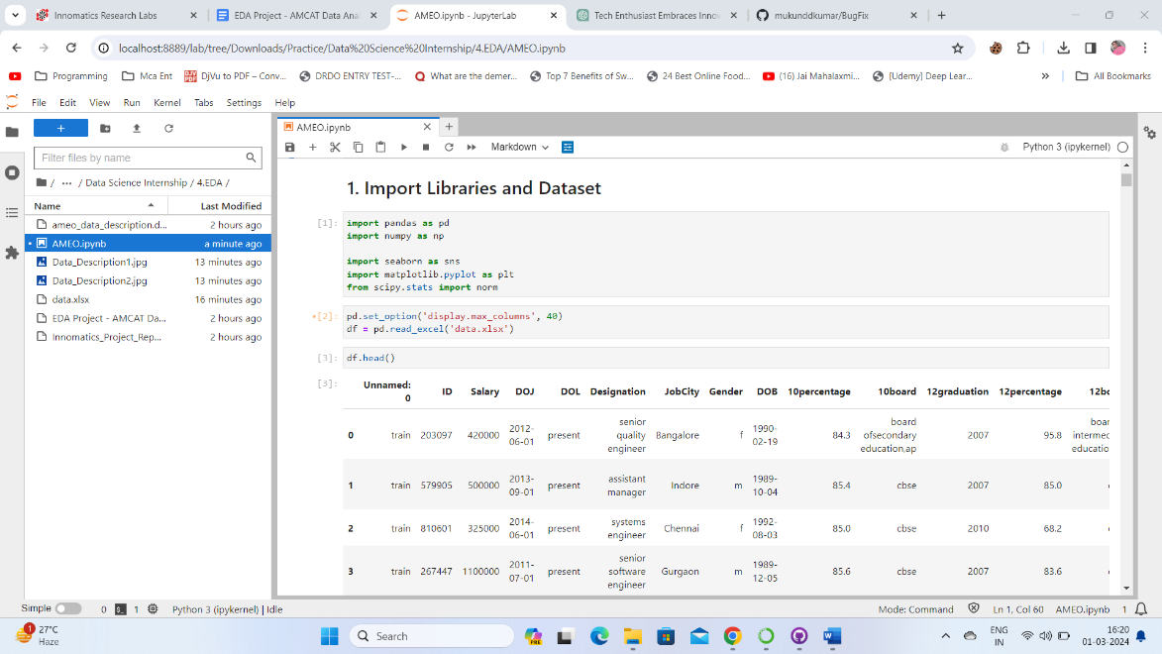

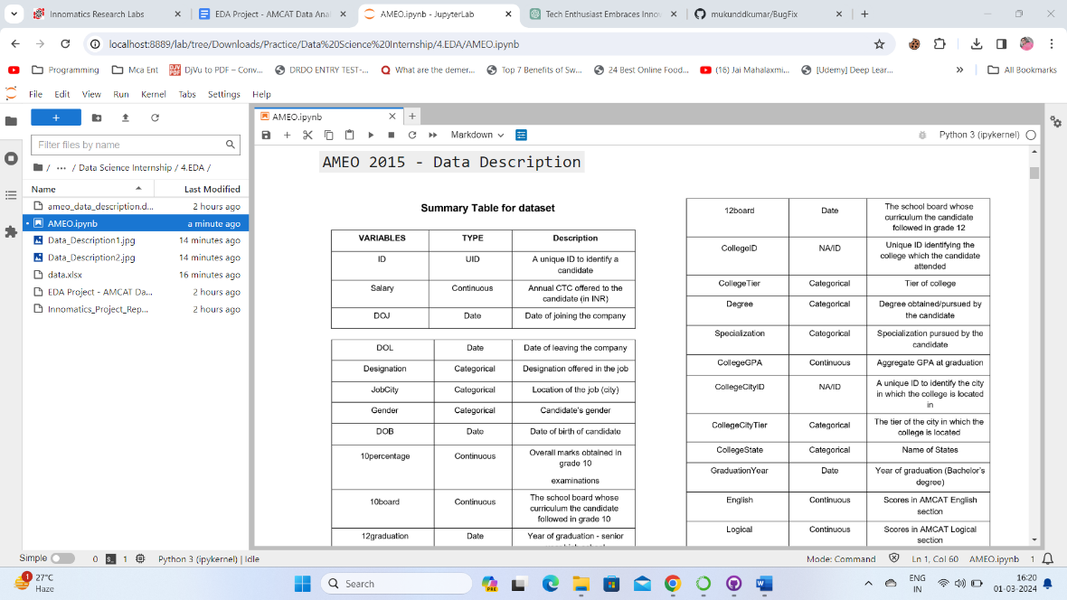

**Data Understanding**

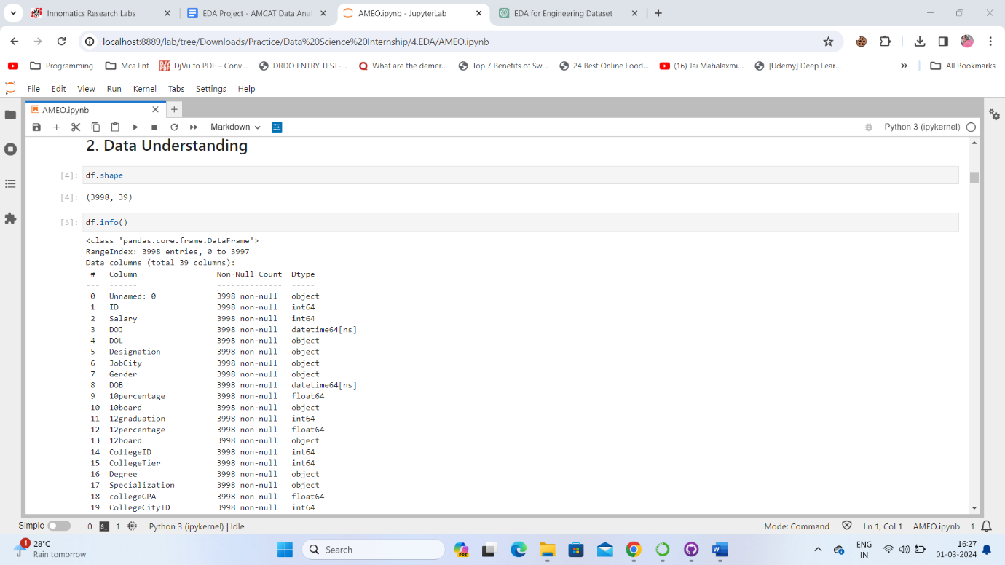

**Dropping unnecessary columns from data**

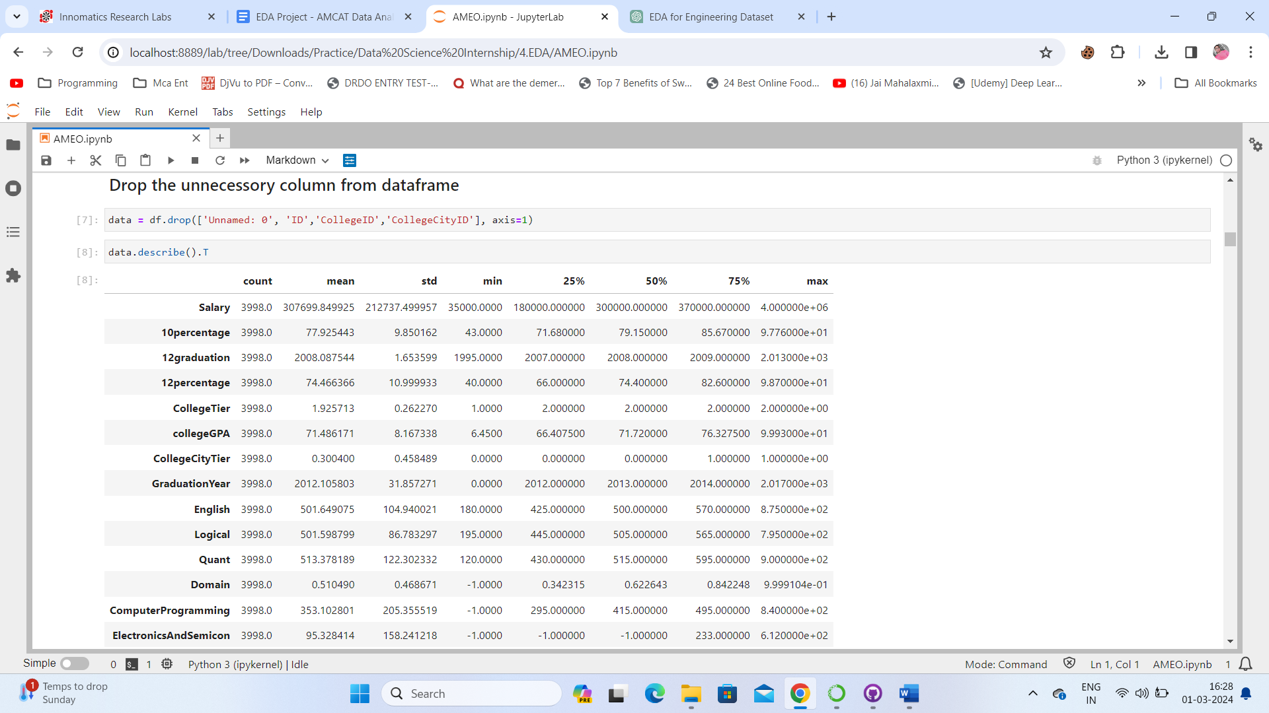

**Data Pre-Processing**

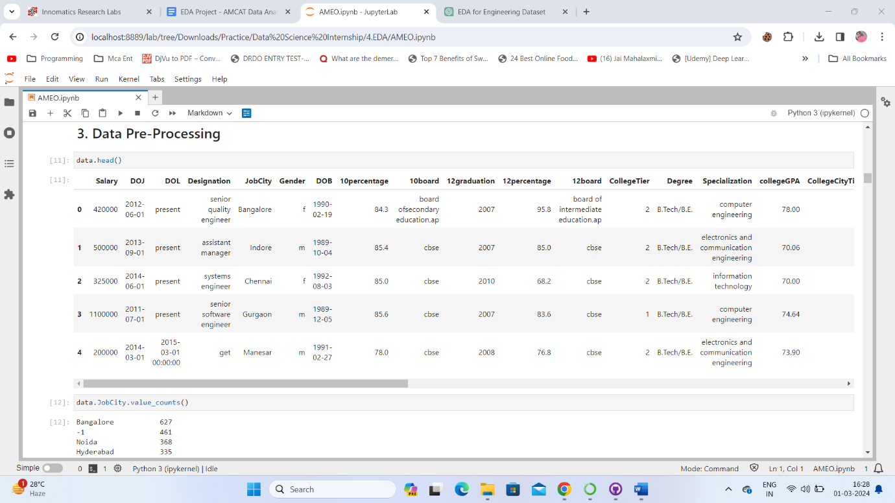

**Data Analysis & Visualization**

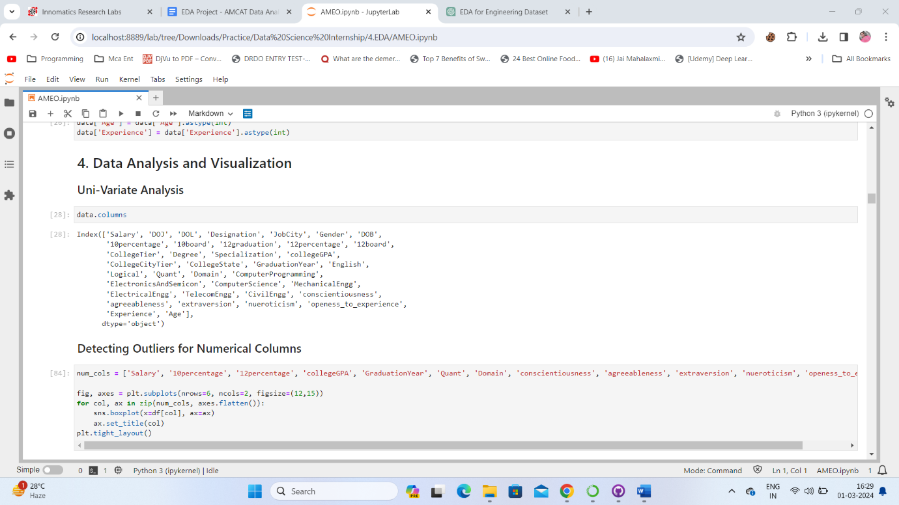

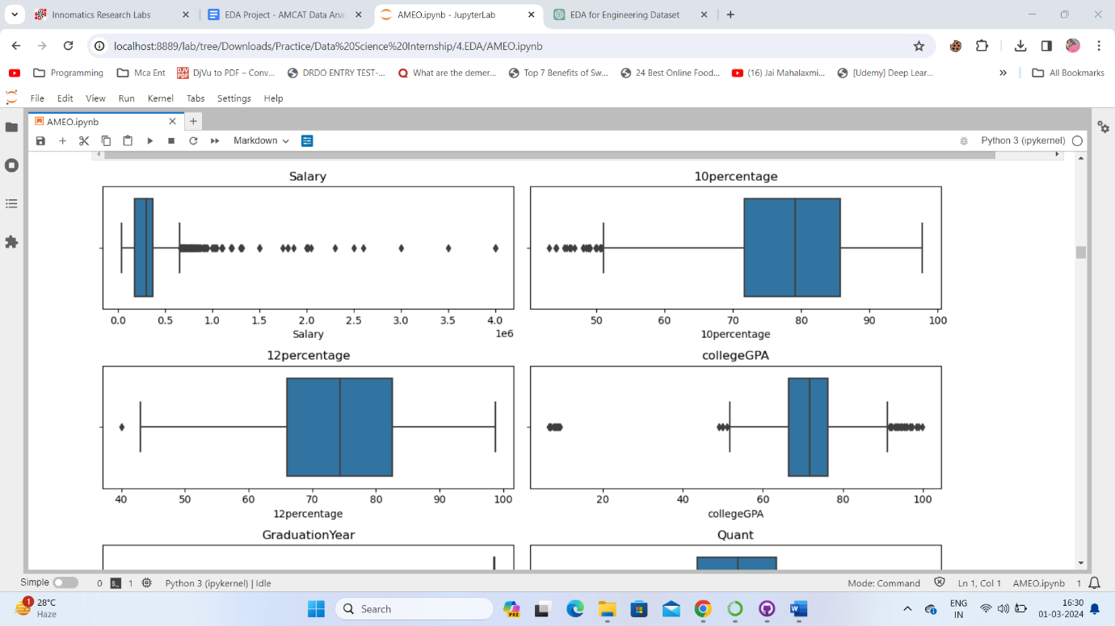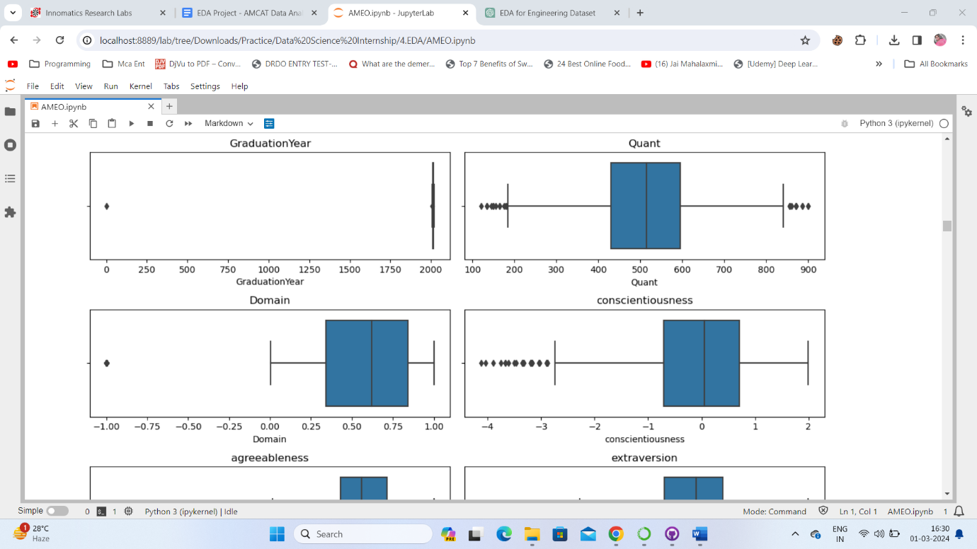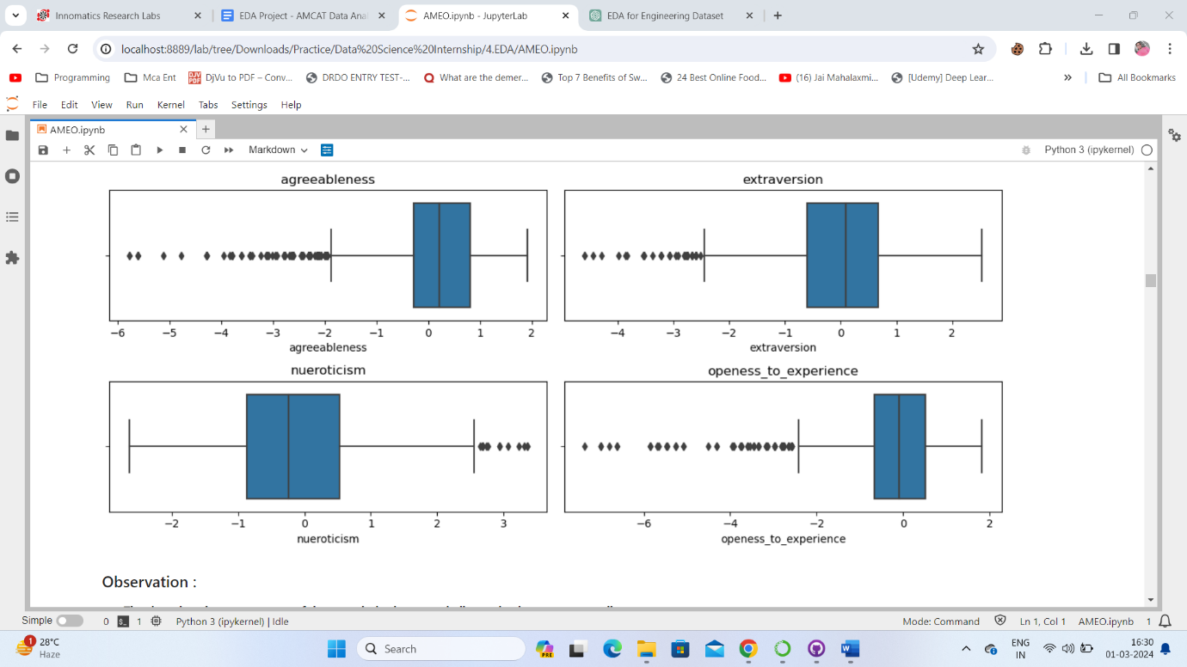

**Observation**

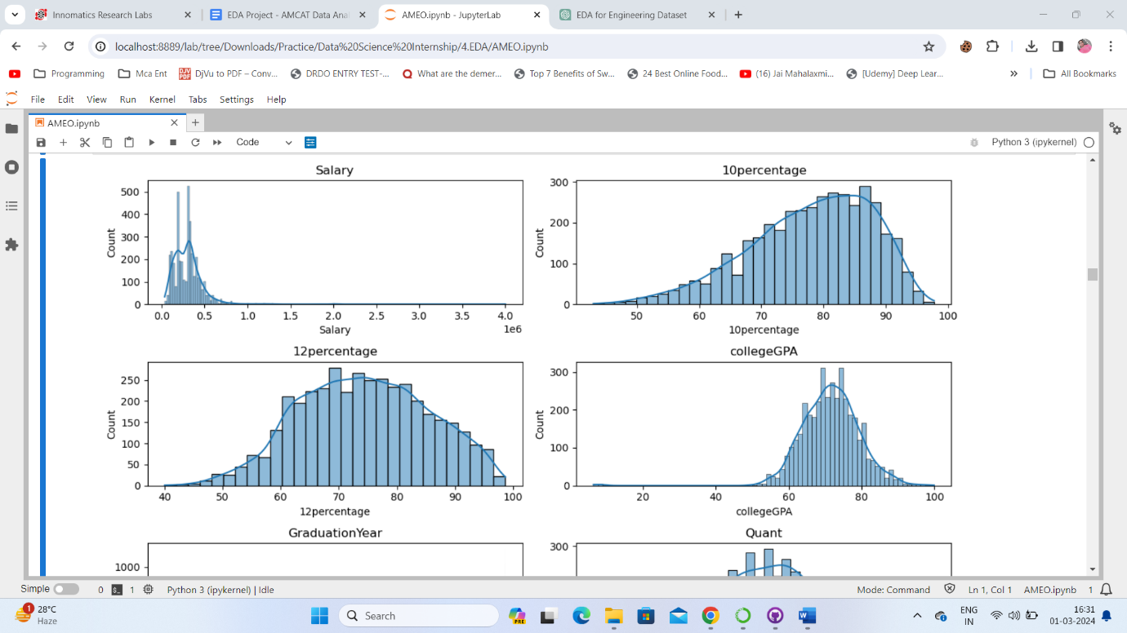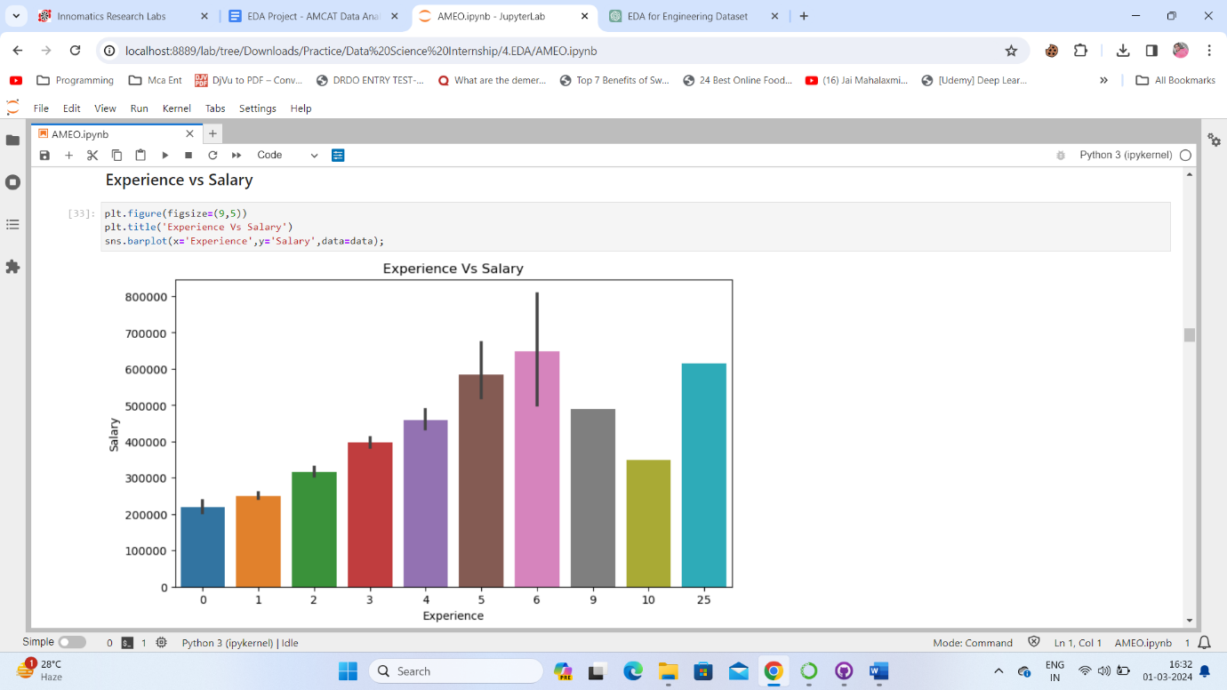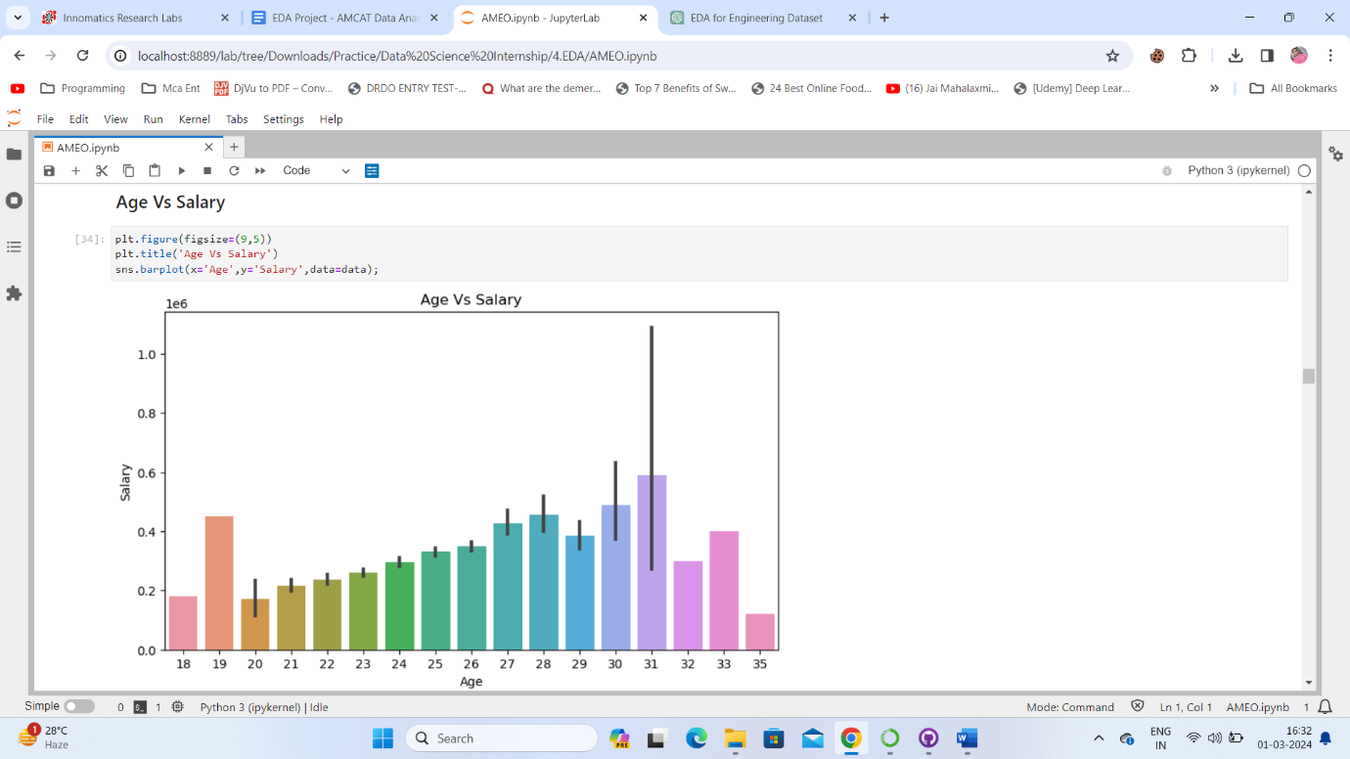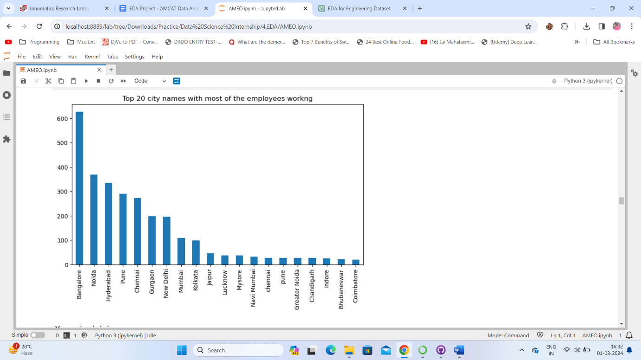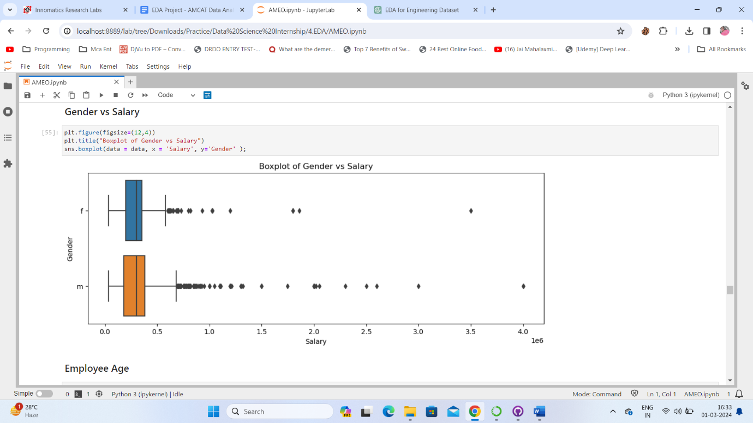

**Conclusion**

The dataset provides comprehensive information about engineering graduates, including demographics, academic performance, and employment outcomes. Univariate and bivariate analyses revealed insights into the distribution of variables and relationships between them. Significant relationships were observed between Gender and Specialization. The distribution of salaries for specific Computer Science Engineering roles was explored. Further statistical analysis and detailed domain expertise are recommended for more precise insights.